**Course: Algorithm**  
**Prof. Prem Nair**  
**Student: Binh Van Tran**  
**ID: 986648**  
**Homework: Lab 13**

1. **Question 1 –** What is the adjacency matrix of the graph G = (V, E) displayed below

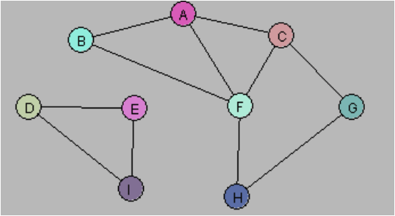

|  |  |  |  |  |  |  |  |  |  |
| --- | --- | --- | --- | --- | --- | --- | --- | --- | --- |
|  | A | B | C | D | E | F | G | H | I |
| A | 0 | 1 | 1 | 0 | 0 | 1 | 0 | 0 | 0 |
| B | 1 | 0 | 0 | 0 | 0 | 1 | 0 | 0 | 0 |
| C | 1 | 0 | 0 | 0 | 0 | 1 | 1 | 0 | 0 |
| D | 0 | 0 | 0 | 0 | 1 | 0 | 0 | 0 | 1 |
| E | 0 | 0 | 0 | 1 | 0 | 0 | 0 | 0 | 1 |
| F | 1 | 1 | 1 | 0 | 0 | 0 | 0 | 1 | 0 |
| G | 0 | 0 | 1 | 0 | 0 | 0 | 0 | 1 | 0 |
| H | 0 | 0 | 0 | 0 | 0 | 1 | 1 | 0 | 0 |
| I | 0 | 0 | 0 | 1 | 1 | 0 | 0 | 0 | 0 |

1. **Question 2 –** Create a Java program to find all components of a graph using DFS

*(See GraphComponent.java)*

1. **Question 3 –** Create a Java program to find all components of a graph using BFS

*(See GraphComponent.java)*